**R Code for Examples in the book**

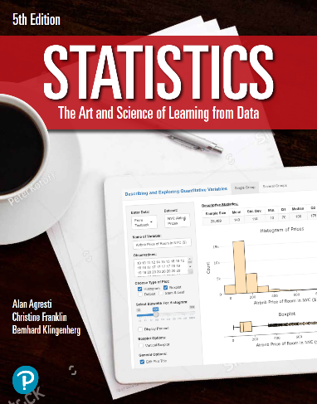

***“Statistics: The Art and Science of Learning from Data”***

**by Agresti, Franklin and Klingenberg, 5th edition**

**Chapter 4**

**Example 4: Drawing Prize Winners – Simple Random Samples**

## To draw a sample of size 2 from 60 raffle tickets

sample(60, 2)

## [1] 9 38

## To obtain all the combinations of drawing samples of size m from n objects, use combn(n, m). For example, to obtain all combinations of samples of size 2 from 8 objects, you can use

combn(5, 2)

## [,1] [,2] [,3] [,4] [,5] [,6] [,7] [,8] [,9] [,10]  
## [1,] 1 1 1 1 2 2 2 3 3 4  
## [2,] 2 3 4 5 3 4 5 4 5 5

## To obtain the number of all possible combinations of samples of size m from n objects, use ncol(combn(n, m)). For example, to obtain the number of all combinations of samples of size 2 from 60 raffle tickets, you can use

ncol(combn(60, 2))

## [1] 1770